aa aa

a a a a a a a a a a a a a a

a a a a a

a a

a a

a a

A A A
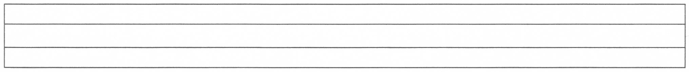
A A A A A A A A A
A A A A A A A A A

A

A
A

A a Aa
AAAAAAAAAA
a a a
A A
a a
aaaaaaaaaaaaaaaaaaaa
aaa
aaa
aaa
aaa
Aaa Aaa
Aaa Aaa
