**GEOMETRİK CİSİMLERİN YÜZLERİ VE YÜZEYLERİ ETKİNLİĞİ**

**Aşağıda tabloda verilen geometrikcisme ait olan yüzleri işaretleyiniz.Kaçar tane olduklarını yazınız.**



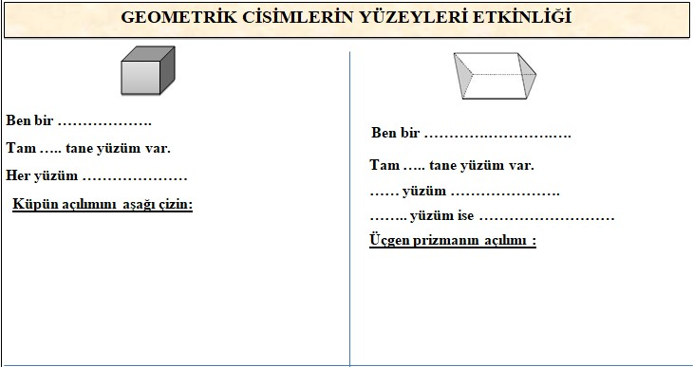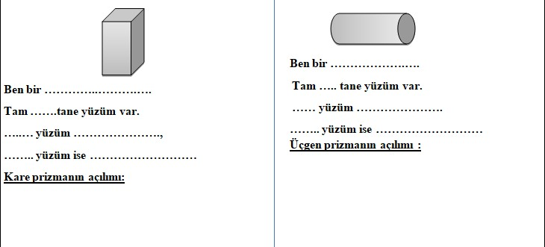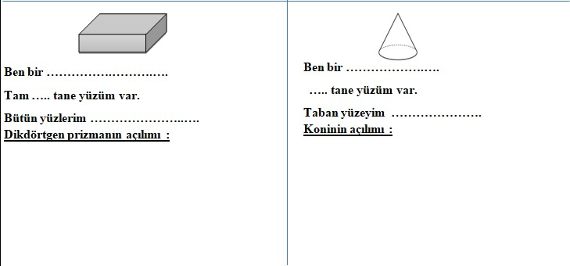

**ZIT(KARŞIT) ANLAMLI SÖZCÜKLERİ EŞLEŞTİRME ETKİNLİK ÇALIŞMASI**

**Rakamların yanındaki kelimelerin zıt anlamlarını harfle verilen kelimelerden bul ve rakamın yanına harfi yazın.**

|  |  |  |  |  |  |  |
| --- | --- | --- | --- | --- | --- | --- |
| **israf** | **1- ..İ.. A** | **olumsuz** |  | **dost** | **18-.Ü. O** | **hür** |

|  |  |  |  |  |  |  |
| --- | --- | --- | --- | --- | --- | --- |
| **varlık** | **2- …. B** | **soğuk** |  | **alt** | **19-…. Ö** | **yokluk** |

|  |  |  |  |  |  |  |
| --- | --- | --- | --- | --- | --- | --- |
| **iyi** | **3- …. C** | **üst** |  | **yaş** | **20-…. P** | **gündüz** |

|  |  |  |  |  |  |  |
| --- | --- | --- | --- | --- | --- | --- |
| **gece** | **4- …. Ç** | **zayıf** |  | **genç** | **21-…. R** | **kalın** |

|  |  |  |  |  |  |  |
| --- | --- | --- | --- | --- | --- | --- |
| **çalışkan** | **5- …. D** | **çok** |  | **aç** | **22-…. S** | **yanlış** |

|  |  |  |  |  |  |  |
| --- | --- | --- | --- | --- | --- | --- |
| **almak** | **6- …. E** | **gündüz** |  | **ileri** | **23 -…. Ş** | **yakın** |

|  |  |  |  |  |  |  |
| --- | --- | --- | --- | --- | --- | --- |
| **doğru** | **7- …. F** | **kısa** |  | **sıcak** | **24-…. T** | **temiz** |

|  |  |  |  |  |  |  |
| --- | --- | --- | --- | --- | --- | --- |
| **az** | **8- …. G** | **tatlı** |  | **güzel** | **25-…. U** | **sığ** |

|  |  |  |  |  |  |  |
| --- | --- | --- | --- | --- | --- | --- |
| **derin** | **9- .U. Ğ** | **tok** |  | **cimri** | **26-…. Ü** | **düşman** |

|  |  |  |  |  |  |  |
| --- | --- | --- | --- | --- | --- | --- |
| **uzak** | **10- …. H** | **cömert** |  | **kar** | **27-… V** | **fakir** |

|  |  |  |  |  |  |  |
| --- | --- | --- | --- | --- | --- | --- |
| **kirli** | **11- …. I** | **yüksek** |  | **alçak** | **28-…. Y** | **dışarı** |

|  |  |  |  |  |  |  |
| --- | --- | --- | --- | --- | --- | --- |
| **şişman** | **12-…. İ** | **tasarruf** |  | **doğu** | **29-…. Z** | **tembel** |

|  |  |  |  |  |  |  |
| --- | --- | --- | --- | --- | --- | --- |
| **dar** | **13- …. J** | **kötü** |  | **sağ** | **30-…. I** | **geri** |

|  |  |  |  |  |  |  |
| --- | --- | --- | --- | --- | --- | --- |
| **uzun** | **14- …. K** | **vermek** |  | **ince** | **31-…. II** | **ihtiyar** |

|  |  |  |  |  |  |  |
| --- | --- | --- | --- | --- | --- | --- |
| **içeri** | **15- …. L** | **kuru** |  | **olumlu** | **32-…. III** | **geniş** |

|  |  |  |  |  |  |  |
| --- | --- | --- | --- | --- | --- | --- |
| **zengin** | **16- …. M** | **zarar** |  | **gece** | **33-…. IV** | **çirkin** |

|  |  |  |  |  |  |  |
| --- | --- | --- | --- | --- | --- | --- |
| **acı** | **17- …. N** | **sol** |  | **esir** | **34-…. V** | **batı** |

**EŞ SESLİ (SESTEŞ) SÖZCÜKLER ETKİNLİK ÇALIŞMASI**

**Eş sesli sözcükleri örnekteki gibi farklı cümlelerde kullanınız.**

**yaş**

Benim yaşım henüz cep telefonu kullanmaya uygun değil.

Halıya su döküldüğü için yaş kalmış.

**kaz**

1.CÜMLE :……………………………………………………………………………………………………..

2.CÜMLE :……………………………………………………………………………………………………..

**yüz**

1.CÜMLE :……………………………………………………………………………………………………..

2.CÜMLE :……………………………………………………………………………………………………..

3.CÜMLE :……………………………………………………………………………………………………..

**yaz**

1.CÜMLE :……………………………………………………………………………………………………..

2.CÜMLE :……………………………………………………………………………………………………..

**bin**

1.CÜMLE :……………………………………………………………………………………………………..

2.CÜMLE :……………………………………………………………………………………………………..

**saç**

1.CÜMLE :……………………………………………………………………………………………………..

2.CÜMLE :……………………………………………………………………………………………………..

**kır**

1.CÜMLE :……………………………………………………………………………………………………..

2.CÜMLE :……………………………………………………………………………………………………..

**gül**

1.CÜMLE :……………………………………………………………………………………………………..

2.CÜMLE :……………………………………………………………………………………………………..

**at**

1.CÜMLE :……………………………………………………………………………………………………..

2.CÜMLE :……………………………………………………………………………………………………..

**kız**

1.CÜMLE :……………………………………………………………………………………………………..

2.CÜMLE :……………………………………………………………………………………………………..

**diz**

1.CÜMLE :……………………………………………………………………………………………………..

2.CÜMLE :……………………………………………………………………………………………………..

**yedi**

1.CÜMLE :……………………………………………………………………………………………………..

2.CÜMLE :……………………………………………………………………………………………………..