**ÇARPMA İŞLEMİ PROBLEMLERİ**

1-Bir inek günde 38 litre süt verirse bir ayda kaç litre süt verir?

|  |  |  |  |  |  |  |  |  |  |  |  |  |
| --- | --- | --- | --- | --- | --- | --- | --- | --- | --- | --- | --- | --- |
|  |  |  |  |  |  |  |  |  |  |  |  |  |
|  |  |  |  |  |  |  |  |  |  |  |  |  |
|  |  |  |  |  |  |  |  |  |  |  |  |  |
|  |  |  |  |  |  |  |  |  |  |  |  |  |
|  |  |  |  |  |  |  |  |  |  |  |  |  |
|  |  |  |  |  |  |  |  |  |  |  |  |  |
|  |  |  |  |  |  |  |  |  |  |  |  |  |
|  |  |  |  |  |  |  |  |  |  |  |  |  |

Cevap: 1140

2- Bir fabrikada bir günde 624 metre kumaş üretiliyorsa 15 günde kaç metre kumaş üretiilir?

|  |  |  |  |  |  |  |  |  |  |  |  |  |
| --- | --- | --- | --- | --- | --- | --- | --- | --- | --- | --- | --- | --- |
|  |  |  |  |  |  |  |  |  |  |  |  |  |
|  |  |  |  |  |  |  |  |  |  |  |  |  |
|  |  |  |  |  |  |  |  |  |  |  |  |  |
|  |  |  |  |  |  |  |  |  |  |  |  |  |
|  |  |  |  |  |  |  |  |  |  |  |  |  |
|  |  |  |  |  |  |  |  |  |  |  |  |  |
|  |  |  |  |  |  |  |  |  |  |  |  |  |
|  |  |  |  |  |  |  |  |  |  |  |  |  |
|  |  |  |  |  |  |  |  |  |  |  |  |  |
|  |  |  |  |  |  |  |  |  |  |  |  |  |

Cevap: 9360

3- Bir rafta 125 tane kitap vardır. 25 raflık bir kitaplıkta kaç tane kitap vardır?

|  |  |  |  |  |  |  |  |  |  |  |  |  |
| --- | --- | --- | --- | --- | --- | --- | --- | --- | --- | --- | --- | --- |
|  |  |  |  |  |  |  |  |  |  |  |  |  |
|  |  |  |  |  |  |  |  |  |  |  |  |  |
|  |  |  |  |  |  |  |  |  |  |  |  |  |
|  |  |  |  |  |  |  |  |  |  |  |  |  |
|  |  |  |  |  |  |  |  |  |  |  |  |  |
|  |  |  |  |  |  |  |  |  |  |  |  |  |
|  |  |  |  |  |  |  |  |  |  |  |  |  |
|  |  |  |  |  |  |  |  |  |  |  |  |  |
|  |  |  |  |  |  |  |  |  |  |  |  |  |
|  |  |  |  |  |  |  |  |  |  |  |  |  |

Cevap: 3125

4- Bir çuvalda 79 kilogram şeker varsa 36 çuvalda kaç kilogram şeker olur?

|  |  |  |  |  |  |  |  |  |  |  |  |  |
| --- | --- | --- | --- | --- | --- | --- | --- | --- | --- | --- | --- | --- |
|  |  |  |  |  |  |  |  |  |  |  |  |  |
|  |  |  |  |  |  |  |  |  |  |  |  |  |
|  |  |  |  |  |  |  |  |  |  |  |  |  |
|  |  |  |  |  |  |  |  |  |  |  |  |  |
|  |  |  |  |  |  |  |  |  |  |  |  |  |
|  |  |  |  |  |  |  |  |  |  |  |  |  |
|  |  |  |  |  |  |  |  |  |  |  |  |  |
|  |  |  |  |  |  |  |  |  |  |  |  |  |

Cevap: 2844

5- Bir bakkal günde 243 tane bisküvi satıyorsa 13 günde kaç tane biskivü satar?

|  |  |  |  |  |  |  |  |  |  |  |  |  |
| --- | --- | --- | --- | --- | --- | --- | --- | --- | --- | --- | --- | --- |
|  |  |  |  |  |  |  |  |  |  |  |  |  |
|  |  |  |  |  |  |  |  |  |  |  |  |  |
|  |  |  |  |  |  |  |  |  |  |  |  |  |
|  |  |  |  |  |  |  |  |  |  |  |  |  |
|  |  |  |  |  |  |  |  |  |  |  |  |  |
|  |  |  |  |  |  |  |  |  |  |  |  |  |
|  |  |  |  |  |  |  |  |  |  |  |  |  |
|  |  |  |  |  |  |  |  |  |  |  |  |  |

Cevap: 3159

6- Bir büfede günde 54 tane tost satılıyorsa 23 günde kaç tane tost satılır?

|  |  |  |  |  |  |  |  |  |  |  |  |  |
| --- | --- | --- | --- | --- | --- | --- | --- | --- | --- | --- | --- | --- |
|  |  |  |  |  |  |  |  |  |  |  |  |  |
|  |  |  |  |  |  |  |  |  |  |  |  |  |
|  |  |  |  |  |  |  |  |  |  |  |  |  |
|  |  |  |  |  |  |  |  |  |  |  |  |  |
|  |  |  |  |  |  |  |  |  |  |  |  |  |
|  |  |  |  |  |  |  |  |  |  |  |  |  |
|  |  |  |  |  |  |  |  |  |  |  |  |  |
|  |  |  |  |  |  |  |  |  |  |  |  |  |
|  |  |  |  |  |  |  |  |  |  |  |  |  |
|  |  |  |  |  |  |  |  |  |  |  |  |  |

Cevap: 1242

7- Bir günlük kahvaltıda 78 gram zeytin tüketen bir aile iki ayda kaç gram zeytin tüketir?

|  |  |  |  |  |  |  |  |  |  |  |  |  |
| --- | --- | --- | --- | --- | --- | --- | --- | --- | --- | --- | --- | --- |
|  |  |  |  |  |  |  |  |  |  |  |  |  |
|  |  |  |  |  |  |  |  |  |  |  |  |  |
|  |  |  |  |  |  |  |  |  |  |  |  |  |
|  |  |  |  |  |  |  |  |  |  |  |  |  |
|  |  |  |  |  |  |  |  |  |  |  |  |  |
|  |  |  |  |  |  |  |  |  |  |  |  |  |
|  |  |  |  |  |  |  |  |  |  |  |  |  |

Cevap: 4680

8- Günde 25 lira harçlık alan bir çocuk 75 gün sonra kaç lira harçlık almış olur?

|  |  |  |  |  |  |  |  |  |  |  |  |  |
| --- | --- | --- | --- | --- | --- | --- | --- | --- | --- | --- | --- | --- |
|  |  |  |  |  |  |  |  |  |  |  |  |  |
|  |  |  |  |  |  |  |  |  |  |  |  |  |
|  |  |  |  |  |  |  |  |  |  |  |  |  |
|  |  |  |  |  |  |  |  |  |  |  |  |  |
|  |  |  |  |  |  |  |  |  |  |  |  |  |
|  |  |  |  |  |  |  |  |  |  |  |  |  |
|  |  |  |  |  |  |  |  |  |  |  |  |  |
|  |  |  |  |  |  |  |  |  |  |  |  |  |

Cevap: 1875

9- Bir mahallede 328 tane ev vardır. Bu evlerin herbirinde 8 kişi yaşıyorsa bu mahallede kaç kişi yaşıyordur?

|  |  |  |  |  |  |  |  |  |  |  |  |  |
| --- | --- | --- | --- | --- | --- | --- | --- | --- | --- | --- | --- | --- |
|  |  |  |  |  |  |  |  |  |  |  |  |  |
|  |  |  |  |  |  |  |  |  |  |  |  |  |
|  |  |  |  |  |  |  |  |  |  |  |  |  |
|  |  |  |  |  |  |  |  |  |  |  |  |  |
|  |  |  |  |  |  |  |  |  |  |  |  |  |
|  |  |  |  |  |  |  |  |  |  |  |  |  |
|  |  |  |  |  |  |  |  |  |  |  |  |  |
|  |  |  |  |  |  |  |  |  |  |  |  |  |

Cevap: 2624

10- Bir kutuda 49 tane kalem varsa 38 kutuda kaç tane kalem vardır?

|  |  |  |  |  |  |  |  |  |  |  |  |  |
| --- | --- | --- | --- | --- | --- | --- | --- | --- | --- | --- | --- | --- |
|  |  |  |  |  |  |  |  |  |  |  |  |  |
|  |  |  |  |  |  |  |  |  |  |  |  |  |
|  |  |  |  |  |  |  |  |  |  |  |  |  |
|  |  |  |  |  |  |  |  |  |  |  |  |  |
|  |  |  |  |  |  |  |  |  |  |  |  |  |
|  |  |  |  |  |  |  |  |  |  |  |  |  |

Cevap: 1862

11- Bir sandıkta 36 tane limon vardır. Pazarda satmak için 24 kasa limon getiren bir pazarcı kaç tane limon satmak için getirmiştir?

|  |  |  |  |  |  |  |  |  |  |  |  |  |
| --- | --- | --- | --- | --- | --- | --- | --- | --- | --- | --- | --- | --- |
|  |  |  |  |  |  |  |  |  |  |  |  |  |
|  |  |  |  |  |  |  |  |  |  |  |  |  |
|  |  |  |  |  |  |  |  |  |  |  |  |  |
|  |  |  |  |  |  |  |  |  |  |  |  |  |
|  |  |  |  |  |  |  |  |  |  |  |  |  |
|  |  |  |  |  |  |  |  |  |  |  |  |  |
|  |  |  |  |  |  |  |  |  |  |  |  |  |
|  |  |  |  |  |  |  |  |  |  |  |  |  |

Cevap: 864

12- Bir sitede 12 apartman vardır. Her apartmanda 7 kat vardır her katta 6 daire varsa bu apartmanda toplam kaç daire vardır?

|  |  |  |  |  |  |  |  |  |  |  |  |  |
| --- | --- | --- | --- | --- | --- | --- | --- | --- | --- | --- | --- | --- |
|  |  |  |  |  |  |  |  |  |  |  |  |  |
|  |  |  |  |  |  |  |  |  |  |  |  |  |
|  |  |  |  |  |  |  |  |  |  |  |  |  |
|  |  |  |  |  |  |  |  |  |  |  |  |  |
|  |  |  |  |  |  |  |  |  |  |  |  |  |
|  |  |  |  |  |  |  |  |  |  |  |  |  |
|  |  |  |  |  |  |  |  |  |  |  |  |  |
|  |  |  |  |  |  |  |  |  |  |  |  |  |

Cevap: 504

13- Herbiri 67 sayfa olan kitaplardan 17 aldım. 5 kitabı okuyamadım okuduğum kitapların toplam sayfası kaçtır?

|  |  |  |  |  |  |  |  |  |  |  |  |  |
| --- | --- | --- | --- | --- | --- | --- | --- | --- | --- | --- | --- | --- |
|  |  |  |  |  |  |  |  |  |  |  |  |  |
|  |  |  |  |  |  |  |  |  |  |  |  |  |
|  |  |  |  |  |  |  |  |  |  |  |  |  |
|  |  |  |  |  |  |  |  |  |  |  |  |  |
|  |  |  |  |  |  |  |  |  |  |  |  |  |
|  |  |  |  |  |  |  |  |  |  |  |  |  |
|  |  |  |  |  |  |  |  |  |  |  |  |  |
|  |  |  |  |  |  |  |  |  |  |  |  |  |

Cevap: 804

**NOKTALAMA İŞARETLERİ**

1.

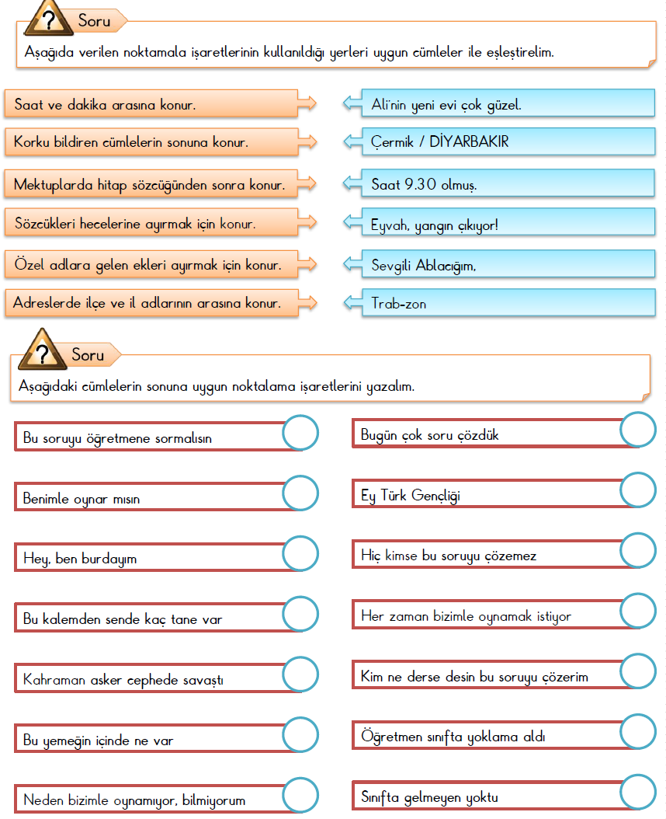

2.



4.

5.

3.