Adı Soyadı:………………………………………………

Öğrencinin Adı Soyadı:……………………………..

Adı Soyadı:……………………………………….

eeeeeeeeeeeeeeeeeeeeeeeeeeeeee
eeeeeeeeeeeeeeeeeeeeeeeeeeeeee
eeeeeeeeeeeeeeeeeeeeeeeeeeeeee eeeeeeeeeeeeeeeeeeeeeeeeeeeeee eeeeeeeeeeeeeeeeeeeeeeeeeeeee eeeeeeeeeeeeeeeeeeeeeeeeeeeeee eeeeeeeeeeeeeeeeeeeeeeeeeeeeee eeeeeeeeeeeeeeeeeeeeeeeeeeeeee eeeeeeeeeeeeeeeeeeeeeeeeeeee ee

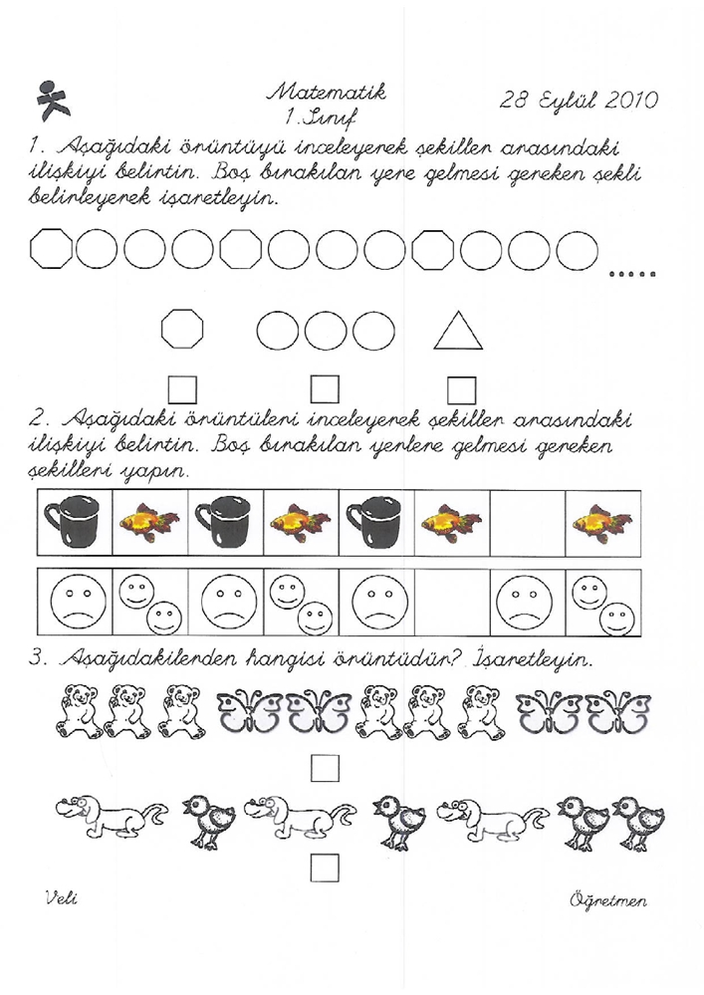
23 Eylül 2011

