***ELDELİ TOPLAMA İŞLEMİ***

*714*

*+267*

*426*

*+105*

*245*

*+605*

*516*

*+397*

*471*

*+369*

*412*

*+228*

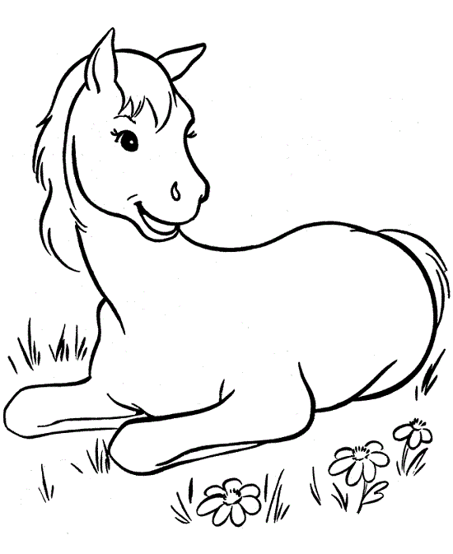

*718*

*+255*

*318*

*+269*

*331*

*+469*

*273*

*+117*

*357*

*+269*

*333*

*+248*

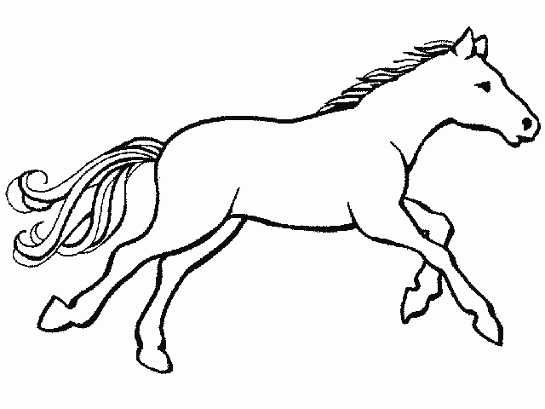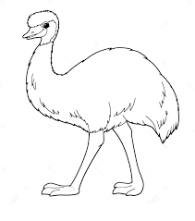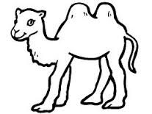

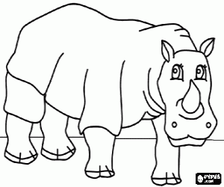

*516*

*+226*

*680*

*+450*

*349*

*+217*

*834*

*+127*

*288*

*+236*

*127*

*+336*

*444*

*+647*

*269*

*+129*

*406*

*+270*

*705*

*+258*

*242*

*+329*

*834*

*+236*

TOPLAMA İŞLEMLERİ

Aşağıdaki eldeli toplama işlemlerini altlarına yapalım.

542

+359

. . .

726

+128

. . .

483

+477

. . .

801

+159

. . .

625

+ 185

. . .

**

*[](http://www.google.ru/imgres?q=smurf&hl=ru&newwindow=1&biw=1366&bih=620&tbs=itp:clipart&tbm=isch&tbnid=w2KpXeAxx89MwM:&imgrefurl=http://www.disneyclips.com/imagesnewb6/smurfs.html&docid=Ep7m4c_8SHFy8M&imgurl=http://www.disneyclips.com/imagesnewb6/imageslwrakr01/smurf19.gif&w=474&h=301&ei=BTTTToztIYTasga2g_WsDA&zoom=1)[](http://www.google.ru/imgres?q=smurf&hl=ru&newwindow=1&biw=1366&bih=620&tbs=itp:clipart&tbm=isch&tbnid=5__GsQbTQKxmMM:&imgrefurl=http://babylife-forum.ru/lofiversion/index.php?t708-200.html&docid=53x7scJr5vm5XM&imgurl=http://s54.radikal.ru/i146/0908/ce/e9164dcd8f05t.jpg&w=240&h=314&ei=BTTTToztIYTasga2g_WsDA&zoom=1)*

471

+369

-------

516

+ 397

-------

687

+ 273

-------

730

+ 173

-------

802

+ 189

-------

606

+ 297

. . .

297

+ 283

. . .

361

+ 289

. . .

573

+ 337

. . .

732

+ 188

. . .

716

+195

. . .

389

+175

. . .

586

+384

. . .

638

+197

. . .

485

+389

. . .



**YAZIM YANLIŞLARI**

