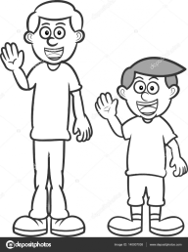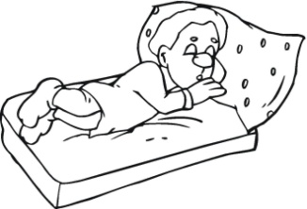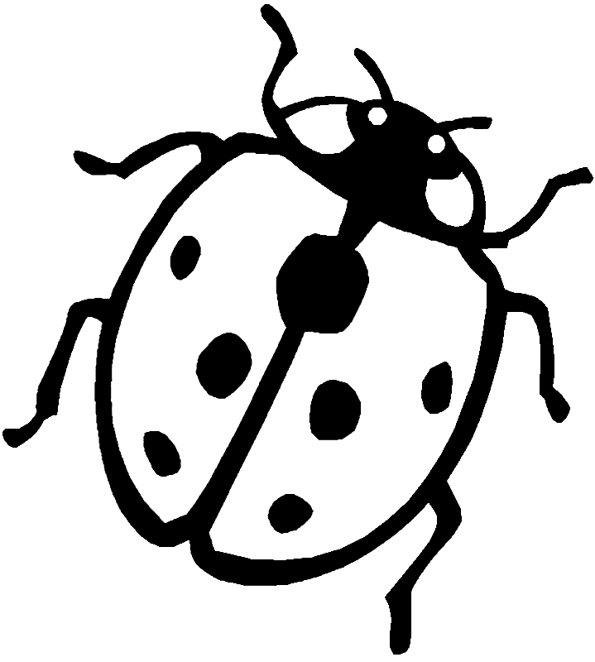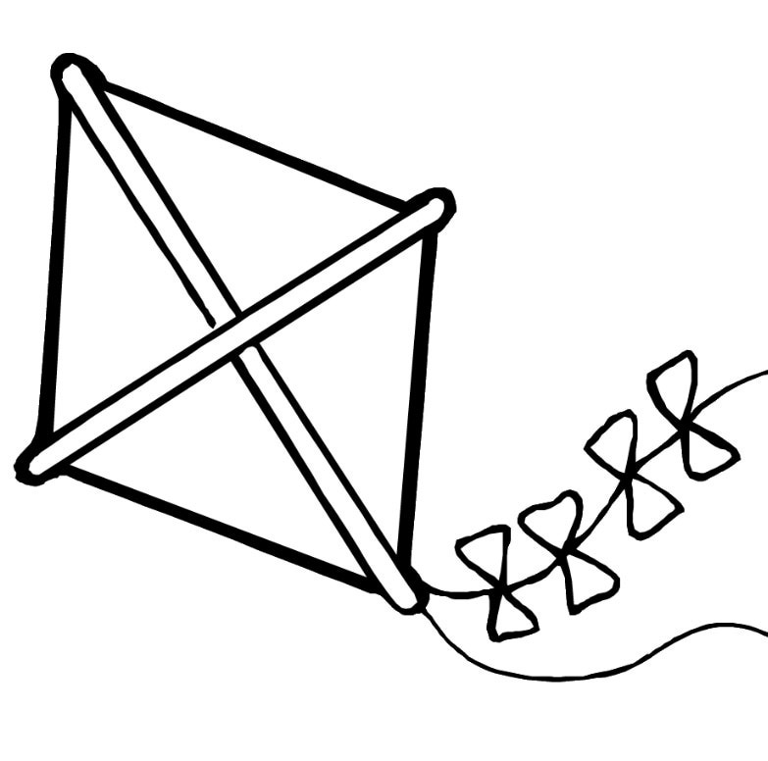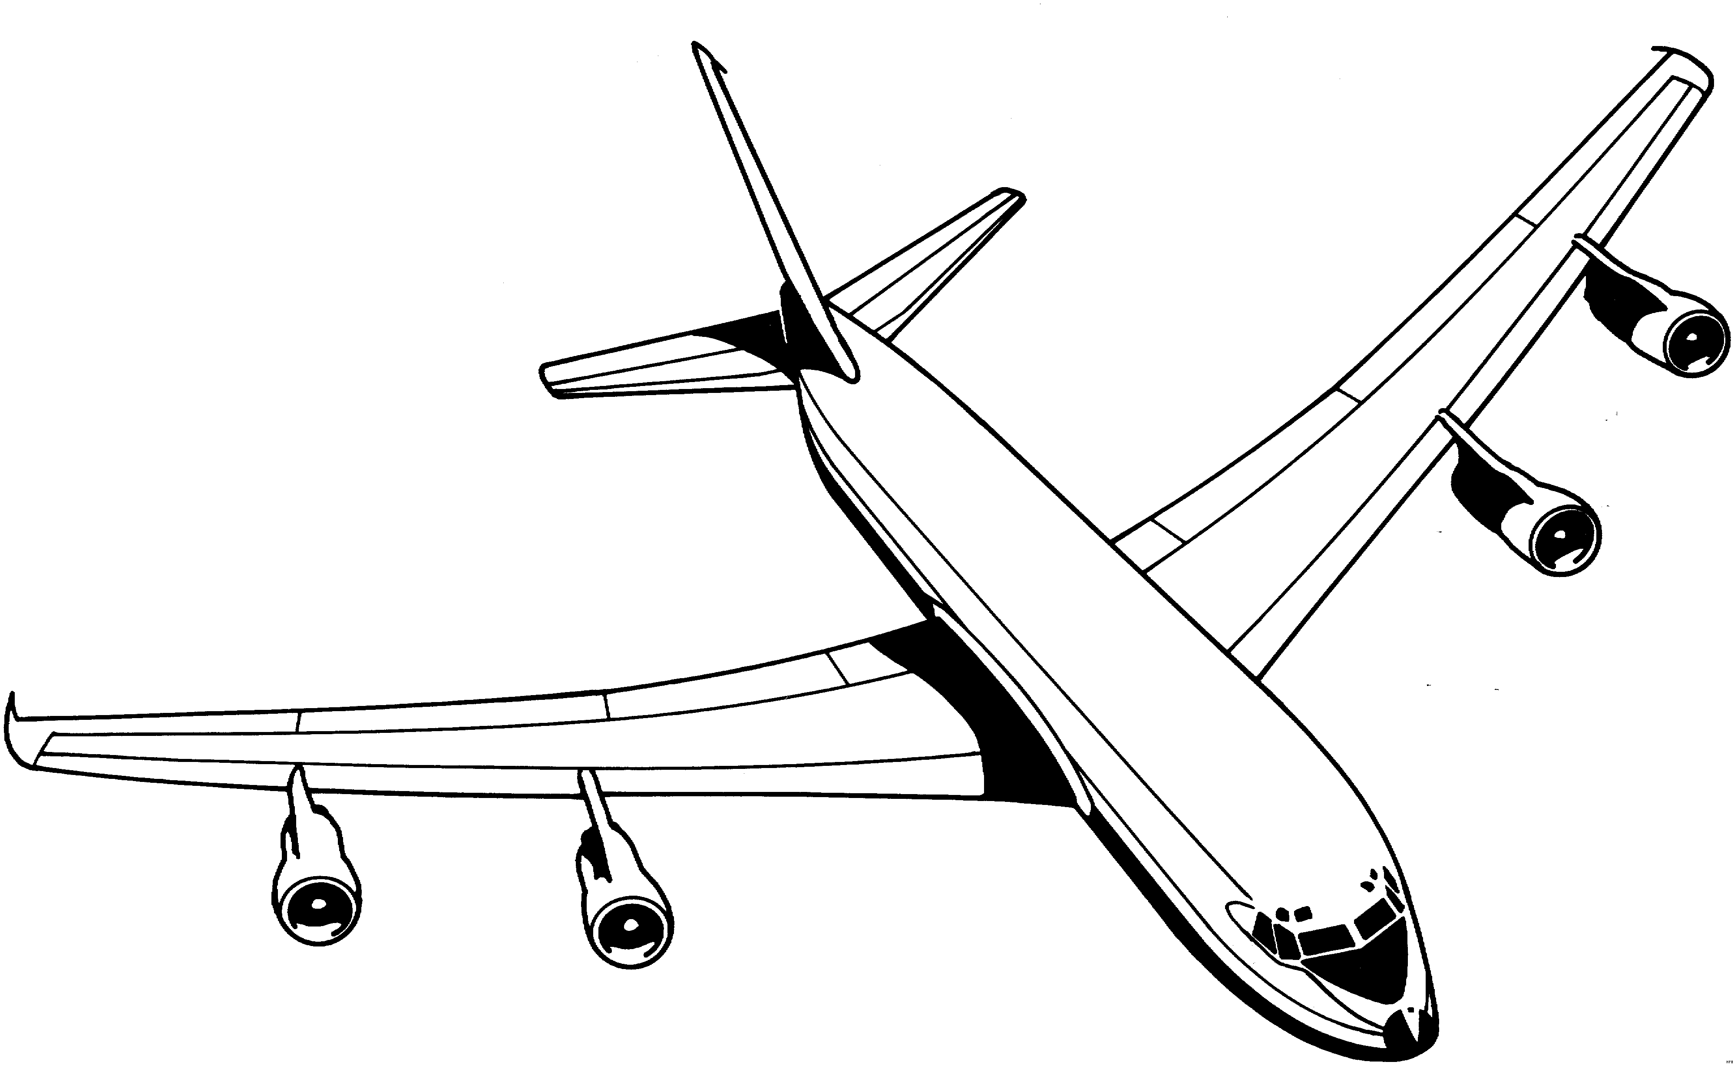

uğur böceği

uyku

uzun

un

uçurtma

uçak

u u

|  |  |  |  |  |  |  |  |  |  |  |  |  |  |  |  |  |  |  |  |  |  |  |  |  |  |  |  |  |  |  |  |  |  |  |  |  |  |  |  |  |  |  |  |  |  |
| --- | --- | --- | --- | --- | --- | --- | --- | --- | --- | --- | --- | --- | --- | --- | --- | --- | --- | --- | --- | --- | --- | --- | --- | --- | --- | --- | --- | --- | --- | --- | --- | --- | --- | --- | --- | --- | --- | --- | --- | --- | --- | --- | --- | --- | --- |
|  |  |  |  |  |  |  |  |  |  |  |  |  |  |  |  |  |  |  |  |  |  |  |  |  |  |  |  |  |  |  |  |  |  |  |  |  |  |  |  |  |  |  |  |  |  |
|  |  |  |  |  |  |  |  |  |  |  |  |  |  |  |  |  |  |  |  |  |  |  |  |  |  |  |  |  |  |  |  |  |  |  |  |  |  |  |  |  |  |  |  |  |  |
|  |  |  |  |  |  |  |  |  |  |  |  |  |  |  |  |  |  |  |  |  |  |  |  |  |  |  |  |  |  |  |  |  |  |  |  |  |  |  |  |  |  |  |  |  |  |

u u

|  |  |  |  |  |  |  |  |  |  |  |  |  |  |  |  |  |  |  |  |  |  |  |  |  |  |  |  |  |  |  |  |  |  |  |  |  |  |  |  |  |  |  |  |  |  |
| --- | --- | --- | --- | --- | --- | --- | --- | --- | --- | --- | --- | --- | --- | --- | --- | --- | --- | --- | --- | --- | --- | --- | --- | --- | --- | --- | --- | --- | --- | --- | --- | --- | --- | --- | --- | --- | --- | --- | --- | --- | --- | --- | --- | --- | --- |
|  |  |  |  |  |  |  |  |  |  |  |  |  |  |  |  |  |  |  |  |  |  |  |  |  |  |  |  |  |  |  |  |  |  |  |  |  |  |  |  |  |  |  |  |  |  |
|  |  |  |  |  |  |  |  |  |  |  |  |  |  |  |  |  |  |  |  |  |  |  |  |  |  |  |  |  |  |  |  |  |  |  |  |  |  |  |  |  |  |  |  |  |  |
|  |  |  |  |  |  |  |  |  |  |  |  |  |  |  |  |  |  |  |  |  |  |  |  |  |  |  |  |  |  |  |  |  |  |  |  |  |  |  |  |  |  |  |  |  |  |

|  |  |  |  |  |  |  |  |  |  |  |  |  |  |  |  |  |  |  |  |  |  |  |  |  |  |  |  |  |  |  |  |  |  |  |  |  |  |  |  |  |  |  |  |  |  |
| --- | --- | --- | --- | --- | --- | --- | --- | --- | --- | --- | --- | --- | --- | --- | --- | --- | --- | --- | --- | --- | --- | --- | --- | --- | --- | --- | --- | --- | --- | --- | --- | --- | --- | --- | --- | --- | --- | --- | --- | --- | --- | --- | --- | --- | --- |
|  |  |  |  |  |  |  |  |  |  |  |  |  |  |  |  |  |  |  |  |  |  |  |  |  |  |  |  |  |  |  |  |  |  |  |  |  |  |  |  |  |  |  |  |  |  |
|  |  |  |  |  |  |  |  |  |  |  |  |  |  |  |  |  |  |  |  |  |  |  |  |  |  |  |  |  |  |  |  |  |  |  |  |  |  |  |  |  |  |  |  |  |  |
|  |  |  |  |  |  |  |  |  |  |  |  |  |  |  |  |  |  |  |  |  |  |  |  |  |  |  |  |  |  |  |  |  |  |  |  |  |  |  |  |  |  |  |  |  |  |

u u

U U

|  |  |  |  |  |  |  |  |  |  |  |  |  |  |  |  |  |  |  |  |  |  |  |  |  |  |  |  |  |  |  |  |  |  |  |  |  |  |  |  |  |  |  |  |  |  |
| --- | --- | --- | --- | --- | --- | --- | --- | --- | --- | --- | --- | --- | --- | --- | --- | --- | --- | --- | --- | --- | --- | --- | --- | --- | --- | --- | --- | --- | --- | --- | --- | --- | --- | --- | --- | --- | --- | --- | --- | --- | --- | --- | --- | --- | --- |
|  |  |  |  |  |  |  |  |  |  |  |  |  |  |  |  |  |  |  |  |  |  |  |  |  |  |  |  |  |  |  |  |  |  |  |  |  |  |  |  |  |  |  |  |  |  |
|  |  |  |  |  |  |  |  |  |  |  |  |  |  |  |  |  |  |  |  |  |  |  |  |  |  |  |  |  |  |  |  |  |  |  |  |  |  |  |  |  |  |  |  |  |  |
|  |  |  |  |  |  |  |  |  |  |  |  |  |  |  |  |  |  |  |  |  |  |  |  |  |  |  |  |  |  |  |  |  |  |  |  |  |  |  |  |  |  |  |  |  |  |

U U

|  |  |  |  |  |  |  |  |  |  |  |  |  |  |  |  |  |  |  |  |  |  |  |  |  |  |  |  |  |  |  |  |  |  |  |  |  |  |  |  |  |  |  |  |  |  |
| --- | --- | --- | --- | --- | --- | --- | --- | --- | --- | --- | --- | --- | --- | --- | --- | --- | --- | --- | --- | --- | --- | --- | --- | --- | --- | --- | --- | --- | --- | --- | --- | --- | --- | --- | --- | --- | --- | --- | --- | --- | --- | --- | --- | --- | --- |
|  |  |  |  |  |  |  |  |  |  |  |  |  |  |  |  |  |  |  |  |  |  |  |  |  |  |  |  |  |  |  |  |  |  |  |  |  |  |  |  |  |  |  |  |  |  |
|  |  |  |  |  |  |  |  |  |  |  |  |  |  |  |  |  |  |  |  |  |  |  |  |  |  |  |  |  |  |  |  |  |  |  |  |  |  |  |  |  |  |  |  |  |  |
|  |  |  |  |  |  |  |  |  |  |  |  |  |  |  |  |  |  |  |  |  |  |  |  |  |  |  |  |  |  |  |  |  |  |  |  |  |  |  |  |  |  |  |  |  |  |

|  |  |  |  |  |  |  |  |  |  |  |  |  |  |  |  |  |  |  |  |  |  |  |  |  |  |  |  |  |  |  |  |  |  |  |  |  |  |  |  |  |  |  |  |  |  |
| --- | --- | --- | --- | --- | --- | --- | --- | --- | --- | --- | --- | --- | --- | --- | --- | --- | --- | --- | --- | --- | --- | --- | --- | --- | --- | --- | --- | --- | --- | --- | --- | --- | --- | --- | --- | --- | --- | --- | --- | --- | --- | --- | --- | --- | --- |
|  |  |  |  |  |  |  |  |  |  |  |  |  |  |  |  |  |  |  |  |  |  |  |  |  |  |  |  |  |  |  |  |  |  |  |  |  |  |  |  |  |  |  |  |  |  |
|  |  |  |  |  |  |  |  |  |  |  |  |  |  |  |  |  |  |  |  |  |  |  |  |  |  |  |  |  |  |  |  |  |  |  |  |  |  |  |  |  |  |  |  |  |  |
|  |  |  |  |  |  |  |  |  |  |  |  |  |  |  |  |  |  |  |  |  |  |  |  |  |  |  |  |  |  |  |  |  |  |  |  |  |  |  |  |  |  |  |  |  |  |

U U

l u u l n u u n lu ul nu un

**lu** lu

**ul** ul

**nu** nu

**un** un

u k k u u m m u

uk ku um mu

**uk** uk

ku ku

u**m** um

**mu** mu

mu m o ku o kul Nu man

mum oku okul Numan

**mum** mum

**oku** oku

**okul** okul

Numan Numan

**Oku** Numan oku. Oku Numan oku.

**Nail o okul.** Nail o okul.

O mum kokulu. O mum kokulu.

**BEŞER BEŞER SAYALIM,YAZALIM**

**BEŞER BEŞER RİTMİK SAYMA**

Beşten başlayarak yüze kadar beşer ritmik sayınız,yazınız.

  

  

  

  

  

5

  

  

  

  

  

  

  

  

  

  

  

  

  

  

  

