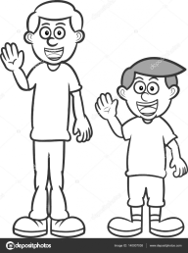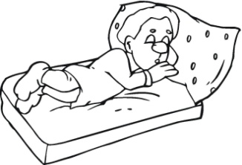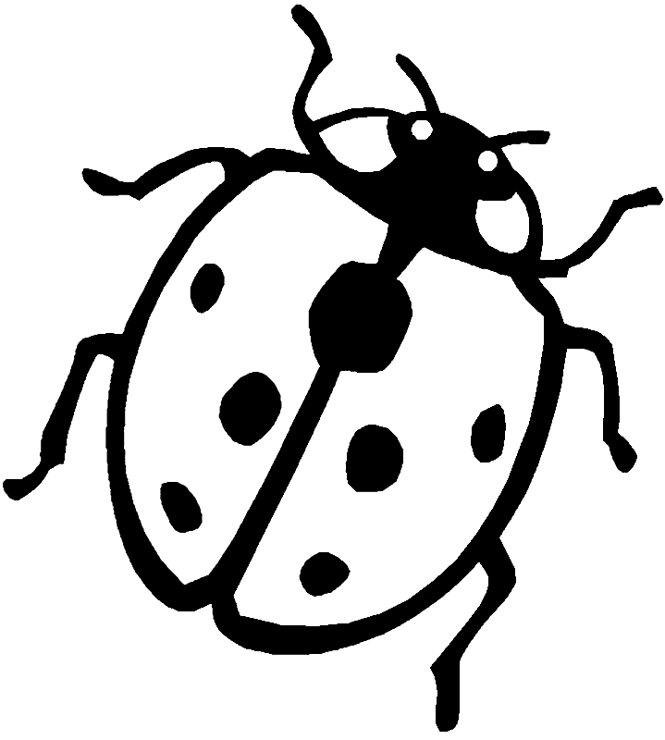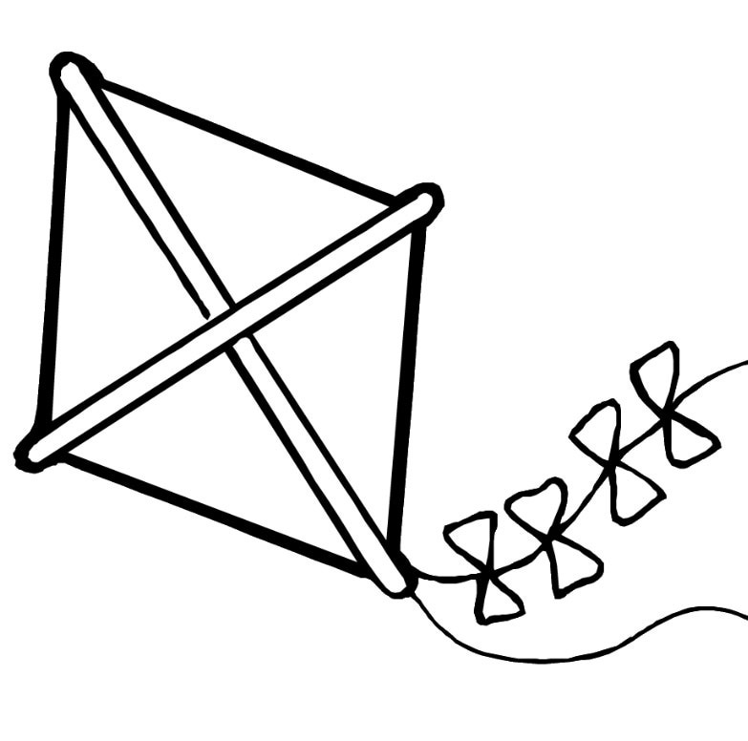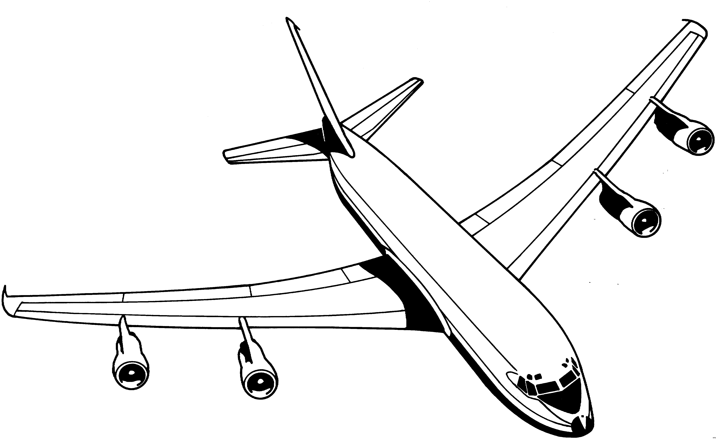

uğur böceği

uyku

uzun

un

uçurtma

uçak

u u **. . . .**

|  |  |  |  |  |  |  |  |  |  |  |  |  |  |  |  |  |  |  |  |  |  |  |  |  |  |  |  |  |  |  |  |  |  |  |  |  |  |  |  |  |  |  |  |  |  |
| --- | --- | --- | --- | --- | --- | --- | --- | --- | --- | --- | --- | --- | --- | --- | --- | --- | --- | --- | --- | --- | --- | --- | --- | --- | --- | --- | --- | --- | --- | --- | --- | --- | --- | --- | --- | --- | --- | --- | --- | --- | --- | --- | --- | --- | --- |
|  |  |  |  |  |  |  |  |  |  |  |  |  |  |  |  |  |  |  |  |  |  |  |  |  |  |  |  |  |  |  |  |  |  |  |  |  |  |  |  |  |  |  |  |  |  |
|  |  |  |  |  |  |  |  |  |  |  |  |  |  |  |  |  |  |  |  |  |  |  |  |  |  |  |  |  |  |  |  |  |  |  |  |  |  |  |  |  |  |  |  |  |  |
|  |  |  |  |  |  |  |  |  |  |  |  |  |  |  |  |  |  |  |  |  |  |  |  |  |  |  |  |  |  |  |  |  |  |  |  |  |  |  |  |  |  |  |  |  |  |

u u **. . . .**

|  |  |  |  |  |  |  |  |  |  |  |  |  |  |  |  |  |  |  |  |  |  |  |  |  |  |  |  |  |  |  |  |  |  |  |  |  |  |  |  |  |  |  |  |  |  |
| --- | --- | --- | --- | --- | --- | --- | --- | --- | --- | --- | --- | --- | --- | --- | --- | --- | --- | --- | --- | --- | --- | --- | --- | --- | --- | --- | --- | --- | --- | --- | --- | --- | --- | --- | --- | --- | --- | --- | --- | --- | --- | --- | --- | --- | --- |
|  |  |  |  |  |  |  |  |  |  |  |  |  |  |  |  |  |  |  |  |  |  |  |  |  |  |  |  |  |  |  |  |  |  |  |  |  |  |  |  |  |  |  |  |  |  |
|  |  |  |  |  |  |  |  |  |  |  |  |  |  |  |  |  |  |  |  |  |  |  |  |  |  |  |  |  |  |  |  |  |  |  |  |  |  |  |  |  |  |  |  |  |  |
|  |  |  |  |  |  |  |  |  |  |  |  |  |  |  |  |  |  |  |  |  |  |  |  |  |  |  |  |  |  |  |  |  |  |  |  |  |  |  |  |  |  |  |  |  |  |

|  |  |  |  |  |  |  |  |  |  |  |  |  |  |  |  |  |  |  |  |  |  |  |  |  |  |  |  |  |  |  |  |  |  |  |  |  |  |  |  |  |  |  |  |  |  |
| --- | --- | --- | --- | --- | --- | --- | --- | --- | --- | --- | --- | --- | --- | --- | --- | --- | --- | --- | --- | --- | --- | --- | --- | --- | --- | --- | --- | --- | --- | --- | --- | --- | --- | --- | --- | --- | --- | --- | --- | --- | --- | --- | --- | --- | --- |
|  |  |  |  |  |  |  |  |  |  |  |  |  |  |  |  |  |  |  |  |  |  |  |  |  |  |  |  |  |  |  |  |  |  |  |  |  |  |  |  |  |  |  |  |  |  |
|  |  |  |  |  |  |  |  |  |  |  |  |  |  |  |  |  |  |  |  |  |  |  |  |  |  |  |  |  |  |  |  |  |  |  |  |  |  |  |  |  |  |  |  |  |  |
|  |  |  |  |  |  |  |  |  |  |  |  |  |  |  |  |  |  |  |  |  |  |  |  |  |  |  |  |  |  |  |  |  |  |  |  |  |  |  |  |  |  |  |  |  |  |

u u **. . . .**

U U **. . . .**

|  |  |  |  |  |  |  |  |  |  |  |  |  |  |  |  |  |  |  |  |  |  |  |  |  |  |  |  |  |  |  |  |  |  |  |  |  |  |  |  |  |  |  |  |  |  |
| --- | --- | --- | --- | --- | --- | --- | --- | --- | --- | --- | --- | --- | --- | --- | --- | --- | --- | --- | --- | --- | --- | --- | --- | --- | --- | --- | --- | --- | --- | --- | --- | --- | --- | --- | --- | --- | --- | --- | --- | --- | --- | --- | --- | --- | --- |
|  |  |  |  |  |  |  |  |  |  |  |  |  |  |  |  |  |  |  |  |  |  |  |  |  |  |  |  |  |  |  |  |  |  |  |  |  |  |  |  |  |  |  |  |  |  |
|  |  |  |  |  |  |  |  |  |  |  |  |  |  |  |  |  |  |  |  |  |  |  |  |  |  |  |  |  |  |  |  |  |  |  |  |  |  |  |  |  |  |  |  |  |  |
|  |  |  |  |  |  |  |  |  |  |  |  |  |  |  |  |  |  |  |  |  |  |  |  |  |  |  |  |  |  |  |  |  |  |  |  |  |  |  |  |  |  |  |  |  |  |

U U **. . . .**

|  |  |  |  |  |  |  |  |  |  |  |  |  |  |  |  |  |  |  |  |  |  |  |  |  |  |  |  |  |  |  |  |  |  |  |  |  |  |  |  |  |  |  |  |  |  |
| --- | --- | --- | --- | --- | --- | --- | --- | --- | --- | --- | --- | --- | --- | --- | --- | --- | --- | --- | --- | --- | --- | --- | --- | --- | --- | --- | --- | --- | --- | --- | --- | --- | --- | --- | --- | --- | --- | --- | --- | --- | --- | --- | --- | --- | --- |
|  |  |  |  |  |  |  |  |  |  |  |  |  |  |  |  |  |  |  |  |  |  |  |  |  |  |  |  |  |  |  |  |  |  |  |  |  |  |  |  |  |  |  |  |  |  |
|  |  |  |  |  |  |  |  |  |  |  |  |  |  |  |  |  |  |  |  |  |  |  |  |  |  |  |  |  |  |  |  |  |  |  |  |  |  |  |  |  |  |  |  |  |  |
|  |  |  |  |  |  |  |  |  |  |  |  |  |  |  |  |  |  |  |  |  |  |  |  |  |  |  |  |  |  |  |  |  |  |  |  |  |  |  |  |  |  |  |  |  |  |

|  |  |  |  |  |  |  |  |  |  |  |  |  |  |  |  |  |  |  |  |  |  |  |  |  |  |  |  |  |  |  |  |  |  |  |  |  |  |  |  |  |  |  |  |  |  |
| --- | --- | --- | --- | --- | --- | --- | --- | --- | --- | --- | --- | --- | --- | --- | --- | --- | --- | --- | --- | --- | --- | --- | --- | --- | --- | --- | --- | --- | --- | --- | --- | --- | --- | --- | --- | --- | --- | --- | --- | --- | --- | --- | --- | --- | --- |
|  |  |  |  |  |  |  |  |  |  |  |  |  |  |  |  |  |  |  |  |  |  |  |  |  |  |  |  |  |  |  |  |  |  |  |  |  |  |  |  |  |  |  |  |  |  |
|  |  |  |  |  |  |  |  |  |  |  |  |  |  |  |  |  |  |  |  |  |  |  |  |  |  |  |  |  |  |  |  |  |  |  |  |  |  |  |  |  |  |  |  |  |  |
|  |  |  |  |  |  |  |  |  |  |  |  |  |  |  |  |  |  |  |  |  |  |  |  |  |  |  |  |  |  |  |  |  |  |  |  |  |  |  |  |  |  |  |  |  |  |

U U **. . . .**

l u u l n u u n lu ul nu un

**lu** lu . . .

**ul** ul . . .

**nu** nu . . .

**un** un . . .

u k k u u m m u

uk ku um mu

**uk** uk . . .

ku ku . . .

u**m** um . . .

**mu** mu . . .

mu m o ku o kul Nu man

mum oku okul Numan

**mum** mum . .

**oku** oku . .

**okul** okul . .

Numan Numan .

**Oku** Numan oku. Oku Numan oku.

**Nail o okul.** Nail o okul.

O mum kokulu. O mum kokulu.

**BEŞER BEŞER SAYALIM,YAZALIM**

**BEŞER BEŞER RİTMİK SAYMA**

Beşten başlayarak yüze kadar beşer ritmik sayınız, yazınız.

  

  

  

  

  

5

  

  

  

  

  

  

  

  

  

  

  

  

  

  

  

